B”

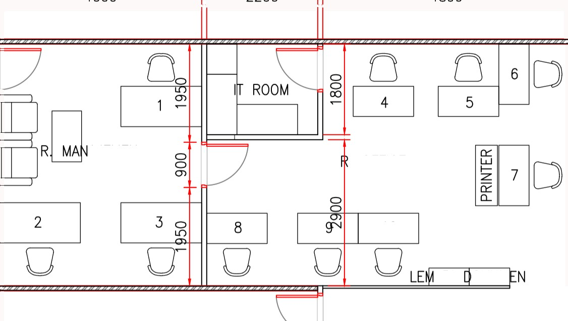



(8)

4800

(9)

(10)

(11 )

(i 2

(15)

(1 4)



(17)

(18)

(1 9)



DUANTIN SURVEYOR SITE CORDINATOR & SOSIAL

KEUANGAN ADMIN HOMAS SURVEYOR

|  |  |  |
| --- | --- | --- |
| ( )  (2) | GENERAL  PROJECT | MANAGER  MANAGER |
| (3) | PROJECT | MANAGER |
| (4) | IT |  |
| (5) | ECOLOGY | SURVEYOR |

SITE MANAGER MEP SITE MANAGER

R. ISTIRAHAT — 1

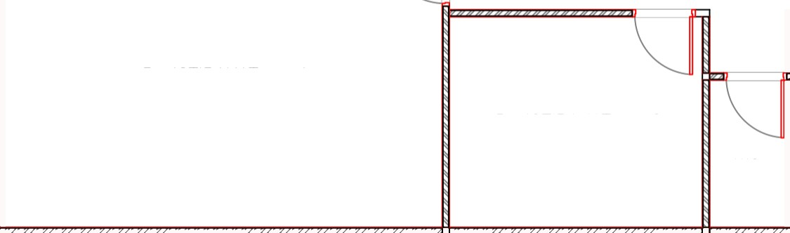

SITE MANAGER INSPECTOR INSPECTOR DUALIN CONTROL DUALIN CONTROL SAFER OFFICER

4000

AJEMEN

2200

4899

OFFICE

10

ARI OKUM

R. ISTIRAHAT — 2

WC

2500

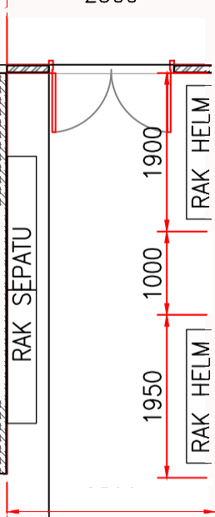

B B B

NPROTE

R. OFFICE

I DO

PANTRY

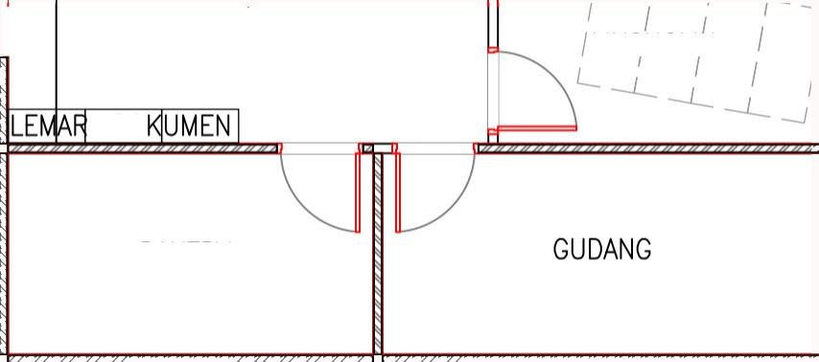

5950

16

17

18

2 00

00

MUSHOLIA

GUDANG

EKSTERNAL

4200

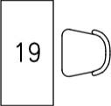

41nñ

SCREEN

I

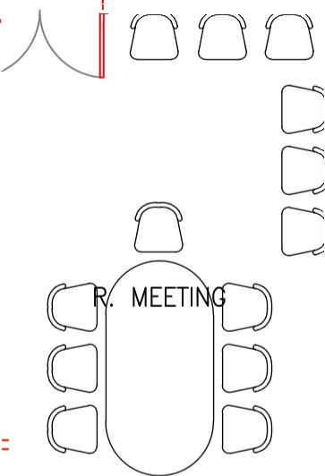

1900

2200

6800

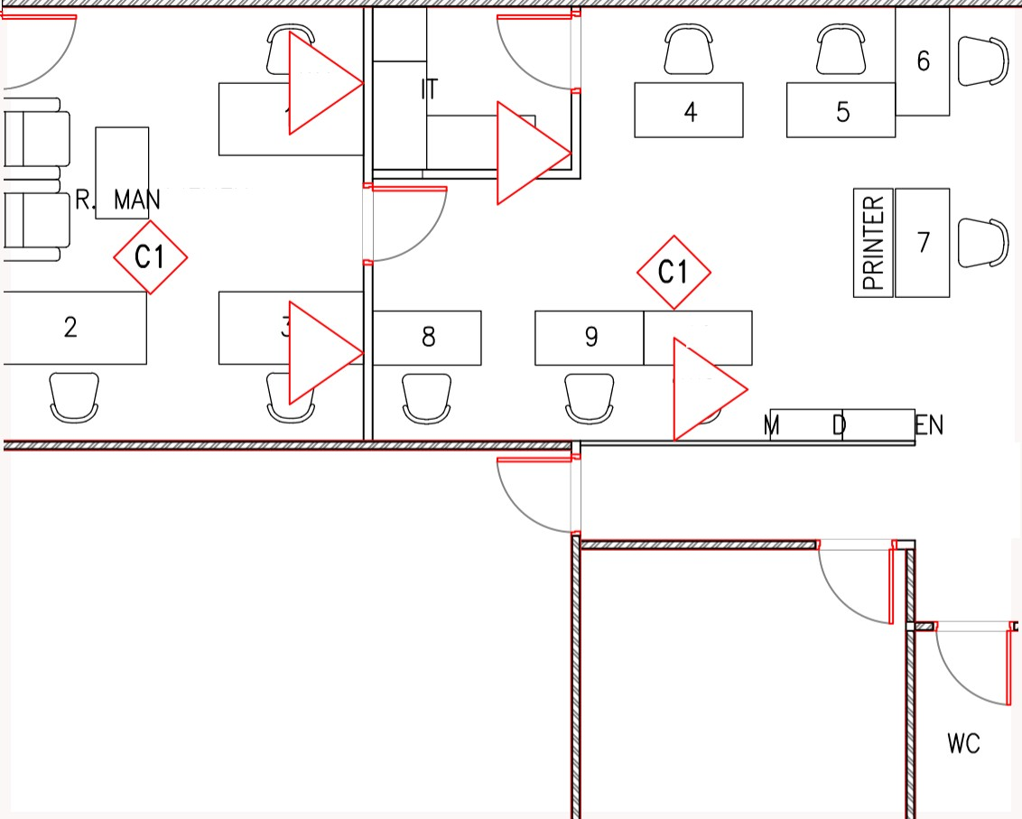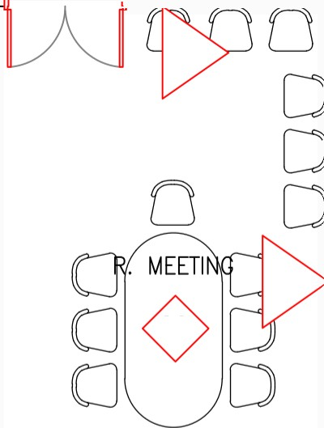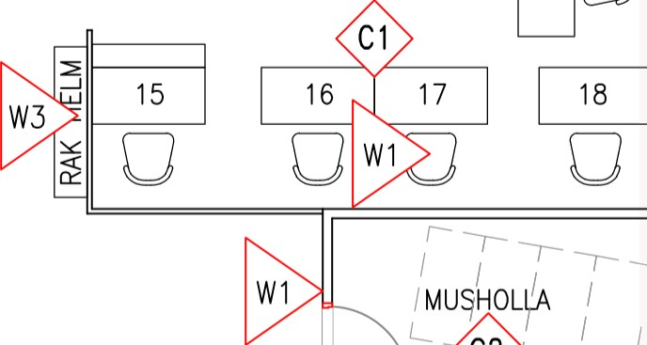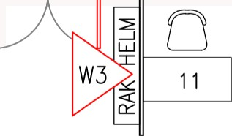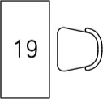

W3

11

1

3

R. OFFICE

C1

W3

16

17

W 1

MUSHOLLA

API DOKUMEN

GUDANG EKSTERNAL

GUDANG

I I

PANTRY

LED

W4 SCREEN

C2

W4

W4

R. ISTIRAHAT — 2

R. ISTIRAHAT — 1

LE ARI OKUM

10

W2

W1

R. OFFICE

AJEMEN

ROOM

W1

W1

|  |  |  |  |  |  |  |  |  |  |  |  |  |  |
| --- | --- | --- | --- | --- | --- | --- | --- | --- | --- | --- | --- | --- | --- |
| LEGEND |  | | | | | | | | | | | | |
| (\\ I ) PARTISI | MULTIPLEK | RANGKA | KAS0 | FIN. | CAT | PUTIH | , | TEBAL | \ 0 | CM | , | TINGGI | 5 MTR |
| (\\2) PARTISI | MULTIPLEK | RANGKA | KAS0 | FIN. | CAT | PUTIH | , | TEBAL | 5 | CM | , | TINGGI | 2 MTR |
| (\\5) PARTISI | MULTIPLEK | RANGKA | KAS0 | FIN. | CAT | PUTIH | , | TEBAL | 5 | CM |  | TINGGI | 1.5 MTR |

|  |  |  |  |  |  |  |  |
| --- | --- | --- | --- | --- | --- | --- | --- |
| (\\4) | PARTISI | BATA TINGGI 0.5 MTR , BILIK TINGGI 2 MTR | / | PARTISI | MULTIPLES RANGKA KAS0 | TEBAL | 10 CM |
| (C \ ) | EXPOSE |  |  |  |  |  |  |

(C2) CEILING MULTIPLES T=3 MM FINISH CAT PUTIH , TINGGI 2,5 MTR

(F\ ) BETON LANTAI KERJA 5 CM , FINISH VINYL

